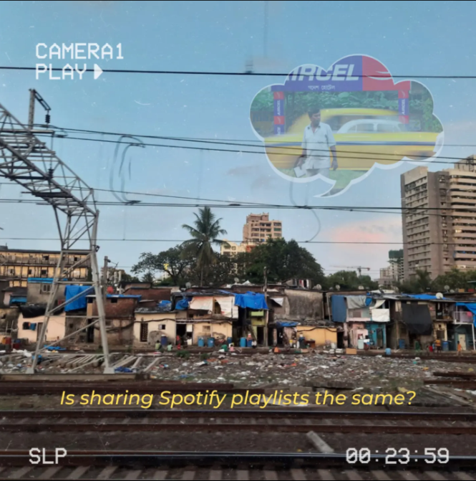
It is 2009. 3G is new.

It costs 351 rupees for 1 GB of data that needs to last a month.

Your crush suggested a new song to you.

You spent 20 minutes looking for the right download link to the song on songs.pk, MP3Skull, WAP.mp3 and pagalworld.com, while having dinner.

It is a long song and will take about 20 minutes to download. You curse your network provider which gives 2.5 G under the guise of 3G. Scammers.

You have an early day tomorrow. So while you're at it, you look up 3 more songs you wanted on your phone and head off to sleep.

You woke up, ready for the reveal.

Two things can happen- you will either find a "download failed" message, in which case you'll start your day with annoyance and disappointment, or the songs indeed get downloaded, and you'll be listening to it before heading out/on the commute like a happy kid with a new toy- having found the content to talk about with your crush. A conversation cue- and a way to show that you care.

You bore yourself to death with the same song on repeat. It doesn't phase you, you waited the whole night for that 3-minute-long piece of "art" that the most beautiful person in the world likes- it is the holy grail to you and makes you whip up mini-dreams about listening to the song together sharing earphones, then falling in love- talking hours at stretch with the 2p/sec tariff- The whole story in your head. Ali from Dhoom is your spirit animal.

You head to your crush's desk and talk about the song. You have an amazing conversation- till she says- "Yeah, my boyfriend suggested this song to me, I'm glad you liked it!".

The dreams are shattered. No earphones will be shared. The horrible pop taste you forced yourself you develop wasn't worth it, neither was setting that song as your callertune- or wasting data to download it. A costly affair, even without being in a relationship.

You head to your local mobile recharge/repair store. Throw your memory card at the shopkeeper's face, and ask him to fill it with all Jagjit Singh songs he has on his computer. Before Arijit, there was Jagjit.

You pay him 10 rs, having all the songs you'll need to overcome the heartbreak.

Is sharing Spotify playlists the same?

